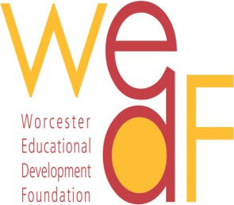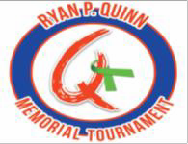

Ryan P. Quinn Memorial Award
for graduating varsity athletes at Burncoat High School

PRESS RELEASE
Contact: April 23, 2018
Louise Clarke, Executive Director for Immediate Release execdir@wedfwps.org
(508) 668-4773

Worcester, MA

Foundation Announces 2018 Recipient

of the
Ryan P. Quinn Memorial Award

The Board of Directors of the Worcester Educational Development Foundation, Inc. (WEDF), is pleased to announce that the recipient of the 2018 Ryan P. Quinn Memorial Award is Jacob Ford. A Senior at Burncoat High School and an accomplished student-athlete, Jacob is the son of Mr. Matthew Ford of Worcester.
Jacob’s impressive accomplishments include: being selected as the Captain of Burncoat High School’s Varsity Baseball Team; being selected, twice, as an Inter-High School All Star Athlete; volunteering for four years with the Community Reading Program; partnering with and assisting classmates in the Life Skills Program during Physical Education and Theatre Arts classes; and leading fundraising initiatives to support fellow athletes.
Ryan P. Quinn, Burncoat High School class of 1996, was a star soccer player and golfer, earning Varsity Letters in both sports. Continuing his education at Salve Regina University, Ryan went on to have a successful career in sales in the medical and pharmaceutical fields. Ryan was a kind and special person, with many devoted friends. Sadly, Ryan passed away in June of 2014. In memory of Ryan, the Quinn Family partnered with the WEDF in 2016, to establish the Ryan P. Quinn Memorial Award for graduating Varsity Athletes of Burncoat High School.
Jacob plans to study Criminal Justice and has been accepted by Colby-Sawyer College, Lasell College, Merrimack College, Plymouth State University, the University of Massachusetts at Lowell, and Western New England University. Jacob will be presented his award and honored on July 16, 2018 at Wachusett Country Club, during the banquet and awards ceremony following the 4th Annual Ryan P. Quinn Memorial Golf Tournament.

On behalf of the Quinn Family, we would like to extend our hearty congratulations to Jacob for being selected as the recipient of this prestigious honor and wish him the best of luck in his educational pursuits.
210 Park Avenue ∙ Suite 224 ∙ Worcester ∙ MA ∙ 01609 www.WEDFWPS.org

